CAPABILITIES DOCUMENT

__________________________________________________________________

ICARUS

Version: 2.0

November 27th, 2017

Developed by Team 08

**Project**: ECSE-211 Design Project: Game of Capture the Flag

**Task**: The goal of this project is to construct an autonomous machine that can play a one-on-one version of the game Capture the Flag, performing tasks such as navigation, localization etc.

**Document Version Number**: 2.0

**Date**: November 27th, 2017

**Author**: Ezz Aboulezz

**Edit History**:

|  |  |
| --- | --- |
| Date | Purpose |
| Oct 16 | Capabilities/skills added |
| Oct 17 | Availabilities added |
| Oct 17 | Document completed |
| Oct 25 | Fixed author to one person |
| Nov 27 | Final edit and re-structure |

1. TABLE OF CONTENTS

2. TEAM MEMBERS........................................................................................................................ 3

3. CAPABILITES.............................................................................................................................. 3

4. POSSIBLE APPLICATION AREAS............................................................................................ 5

5. AVAILABILITY........................................................................................................................... 6

6. GLOSSARY OF TERMS.............................................................................................................. 7

1. **TEAM MEMBERS**

|  |  |  |
| --- | --- | --- |
| Team Member | Email | Role |
| Valkanas, Antonios | [antonios.valkanas@mail.mcgill.ca](mailto:antonios.valkanas@mail.mcgill.ca) | Design Team Manager |
| Aboulezz, Ezz | [ezz.abouelezz@mail.mcgill.ca](mailto:ezz.abouelezz@mail.mcgill.ca) | Documentation Team Manager |
| Di Piazza, Raphaël | [raphael.dipiazza@mail.mcgill.ca](mailto:raphael.dipiazza@mail.mcgill.ca) | Software Team Engineer |
| Tao, Borui | [borui.tao@mail.mcgill.ca](mailto:borui.tao@mail.mcgill.ca) | Software Team Manager |
| Kang, Hailey | [heejung.kang@mail.mcgill.ca](mailto:heejung.kang@mail.mcgill.ca) | Hardware Team Manager |
| Décéus, Oscar | [oscar.deceus@mail.mcgill.ca](mailto:oscar.deceus@mail.mcgill.ca) | Testing Team Manager |

1. **CAPABILITIES**

**\*Each member rates their skills out of 10 and roles are picked accordingly.**

|  |  |  |  |  |  |
| --- | --- | --- | --- | --- | --- |
| Member | Electrical Engineering | Software Engineering | Mechanical Engineering | Management Experience | Documentation |
| Antonios | 10 | 7 | 5 | 8 | 6 |
| Ezz | 9 | 7 | 5 | 6 | 8 |
| Raphael | 7 | 10 | 3 | 6 | 6 |
| Borui | 7 | 10 | 3 | 7 | 7 |
| Hailey | 9 | 7 | 6 | 6 | 7 |
| Oscar | 8 | 10 | 4 | 7 | 6 |

**\*This table will decide what secondary roles each member will be assigned.**

|  |  |
| --- | --- |
| Team Member | Capabilities |
| Antonios Valkanas | Electrical Engineering student  Good organization and management experience  Intermediate software skills |
| Ezz Aboulezz | Electrical engineering student  Organized with documentation experience  Decent software and testing skills |
| Raphael Di Piazza | Software Engineering student  Advanced Java experience  Good at formatting and organizing documents and code. |
| Borui Tao | Software engineering student  Advanced Programming experience  Excellent testing skills |
| Oscar Deceus | Computer engineering student  Good testing and analyzing skills  Excellent software development skills |
| Hailey Kang | Electrical Engineering student  Decent mechanical/hardware skills  Knowledge of applied physics in dynamics and mechanics |

1. **POSSIBLE APPLICATION AREAS**

\***Tasks and areas where each member will operate.**

|  |  |
| --- | --- |
| Task | Team Member |
| Mechanical design | Hailey: Leader  Oscar: Engineer  Antonios: Engineer |
| Software architecture | Borui: Leader  Raphael: Engineer  Oscar: Engineer |
| R&D to calibrate sensors, component testing | Oscar: Leader  Borui: Engineer  Raphael: Engineer |
| Management & Documentation | Antonios: Leader  Ezz: Leader  Hailey: Organizer |
| Design tests/Integration testing | Oscar: Leader  Borui: Engineer  Raphael: Engineer  Ezz: Engineer |

1. **AVAILABILITY**

\***Timetables filled out by each member to represent free time and midterms**

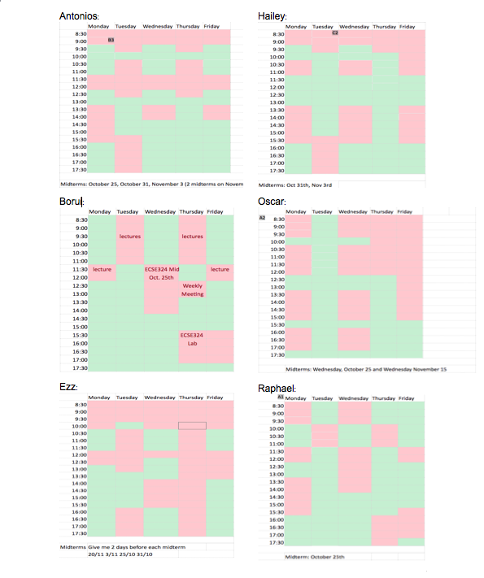

List of Midterm dates:

\***Dates when members will not be available 1-3 days before their midterm**

October 25th: Antonios, Borui, Ezz, Oscar, and Raphael

October 31st: Antonios, Ezz, and Hailey

November 3rd: Antonios, Ezz, and Hailey

November 15th: Oscar

November 20th: Ezz

1. **GLOSSARY OF TERMS**

R&D: Research and Development phase

Integration tests**:** Integrate all software and hardware components and test design